AI LITERACY COURSE
How To Build It
Turning a public dataset into a working app, by directing an AI · Worked example: Arrival, honest A&E waits for Hong Kong
You are going to build a real, working web application. You will not type a single line of code. You will find a dataset nobody has made useful, decide what it is for, choose the tools by asking rather than guessing, direct an AI to build it, and then, the part that actually matters, check whether it told you the truth.
The worked example is Arrival, which takes Hong Kong's public A&E waiting times and shows whether today is normal. Every prompt in this document is one you can copy. Swap the dataset at the start and the same eighteen prompts build something else entirely.
BEFORE YOU START
One laptop per group that can install software, internet, and roughly three hours. No prior coding. No prior AI experience. A free Google account for one of the steps. Work in pairs at the keyboard and swap every section, because the person typing learns the least.

Step 0 · Pick your AI, and understand the one rule
This tutorial shows Claude Code, because it is what the finished project was built in. It is not the only option and nothing here depends on it. Any AI that can create files in a folder and run commands will follow the same eighteen prompts.
Tool | Works for this? | What changes
Claude Code | Yes, shown here | Nothing. This is the reference.
Hermes Desktop | Yes | Different window, same prompts.
ChatGPT (with a code tool) | Yes | Different window, same prompts.
DeepSeek harness | Yes | Different window, same prompts.
Tencent WorkBuddy | Yes | Different window, same prompts.
A plain chatbot, no file access | Partly | You must copy each file out by hand. Slow, but it works.

Where this document says a slash command like /mcp, a tool without that command will still do the same job if you ask in plain words. The moves are the same everywhere. Only the buttons differ.

0.1 Set up your workspace
1. Install your chosen AI tool and sign in.
2. Make one new, empty folder on your Desktop. Call it something like arrival.
3. Open that folder in the tool. In Claude Code that means opening a terminal in the folder and typing claude.
4. Everything from here happens inside that one folder. Nothing else on your computer is touched.
THE ONE RULE FOR THIS WHOLE PROJECT
You are not the coder. You are the client, the editor and the inspector. Your job is to decide what is worth building, to insist on knowing where every number came from, and to say no when the AI produces something confident and wrong. An AI will happily invent a plausible number. Catching that is the entire skill this project teaches.

Step 1 · Find a dataset worth building on
Most student projects fail here, not later. They pick data that is already well served, or data so thin that nothing honest can be said about it. Spend real time on this step.

1.1 Where to look
Source | What is there
data.gov.hk | Around 5,000 Hong Kong government datasets. Transport, health, weather, housing, environment. Free, no account.
Your city's open data portal | Almost every major city has one. Search “<city> open data portal”.
data.worldbank.org | Country-level economics and development, decades deep.
Kaggle Datasets | Huge, but mostly already analysed to death. Weakest option for finding an unserved question.

1.2 The four questions a dataset must survive
Before you fall in love with a dataset, make it answer these. If it fails even one, move on. It is not a bad dataset, it is a bad dataset for this.
Question | Why it decides everything
Is it updated, or frozen? | A dataset updated every 15 minutes lets you build something live. A one-off 2019 report only lets you build a chart.
Does anyone already make it useful? | If a good app already exists, you are doing homework, not building. Look for data that is published and then abandoned.
Can you get its history? | One reading tells you nothing. To say “today is unusual” you need what usual looks like.
Is there something it genuinely cannot tell you? | This sounds like a weakness. It is the best sign of all. It is where the honest version of your project lives.

PROMPT 1 Evaluating a dataset
I am a student with no coding background, building a small web app with an AI.
I am considering this dataset: <paste the dataset page URL>
Answer these four questions, briefly and concretely:
1. How often is it updated, and can I get its past values as well as today's?
2. Do apps or websites already exist that make this data useful to the public?
3. What could I say with this data that nobody is currently saying?
4. What can this data NEVER tell me, no matter how clever I am?
For question 4, be blunt. Do not soften it. I want to know the limit before
I build on top of it, not after.
Question 4 is the one that matters. Keep the answer. You will need it in Step 6.

1.3 The worked example
Hong Kong's Hospital Authority publishes how long each of the 18 emergency departments expects a patient arriving now to wait. It passes all four questions, which is why it was chosen.
The dataset page: https://data.gov.hk/en-data/dataset/hospital-hadata-ae-waiting-time
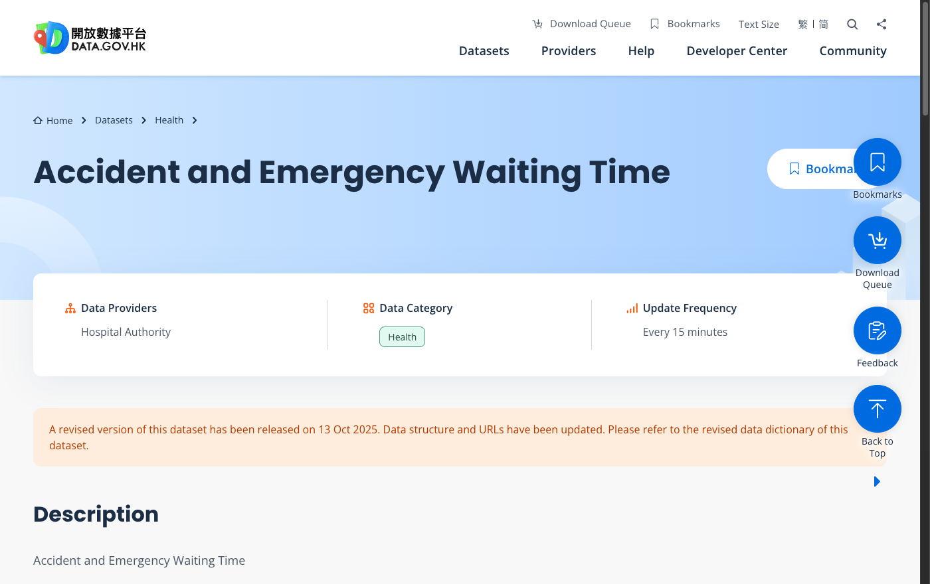
Updated every 15 minutes, by the Hospital Authority. That update frequency is what makes a live app possible rather than a static chart.
Scroll down that page and you reach the actual files. Seven of them: the same data in English, Traditional Chinese and Simplified Chinese, as JSON and as a spreadsheet.
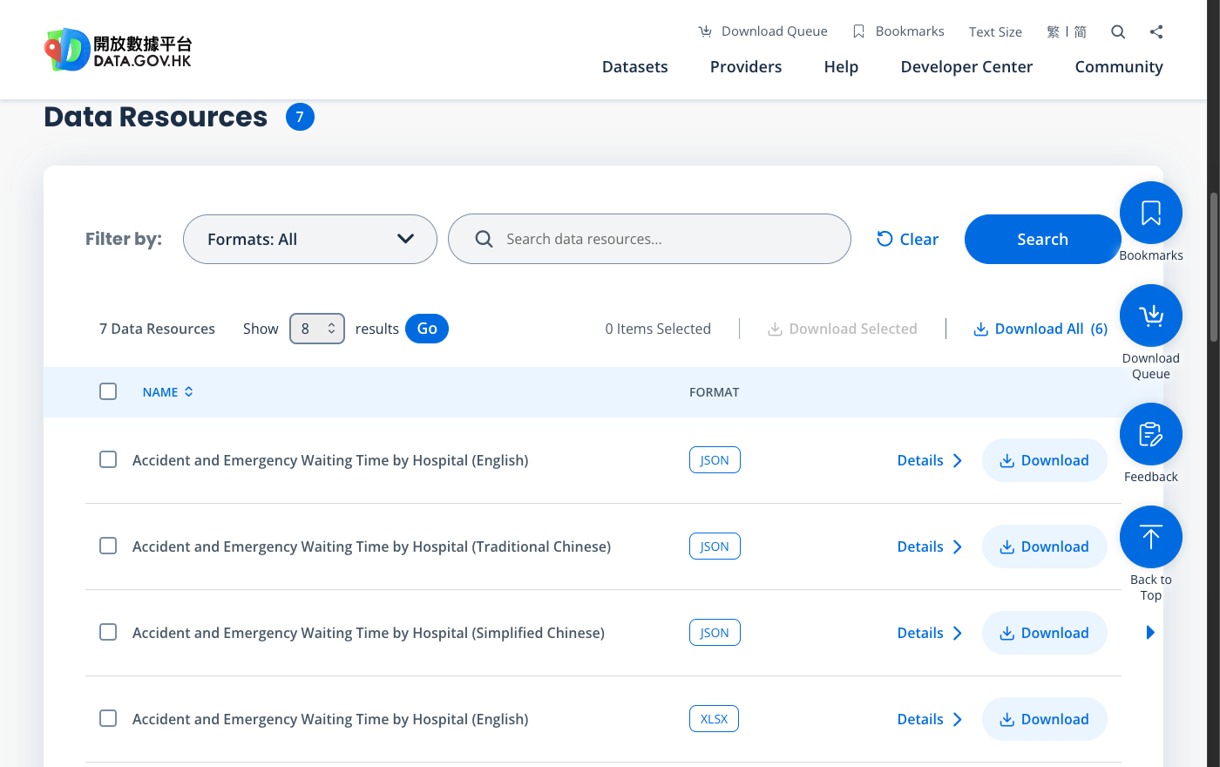
The downloads. Take the English JSON: JSON is the format an AI will find easiest to work with, and you do not need the spreadsheet.
Open the JSON link in your browser. This is the whole dataset, live:
https://www.ha.org.hk/opendata/aed/aedwtdata2-en.json
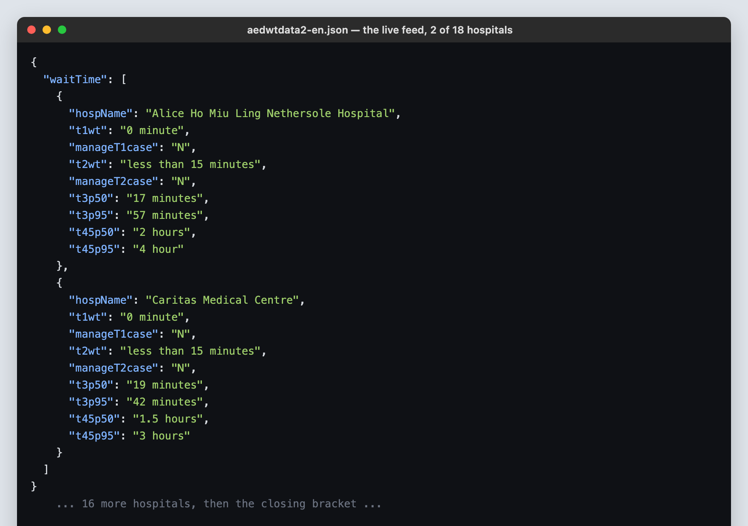
Two of the eighteen hospitals. Ugly, but complete and free. Every number in the finished app comes from this.
Field | Meaning
hospName | Which emergency department
t1wt, t2wt | Triage I and II, the critical cases, seen immediately
t3p50 | Triage III: half of arriving patients are seen within this
t3p95 | Triage III: 19 in 20 are seen within this. The long wait.
t45p50, t45p95 | The same two figures for triage IV and V, the less urgent

NOTICE THE PROBLEM ALREADY
This feed gives you one number per department, for right now. Is 17 minutes at Alice Ho good or bad? On a Tuesday afternoon? Nothing here tells you. That gap, published but not made meaningful, is the entire product.

1.4 The step almost everyone misses
To say whether today is normal, you need months of history. The obvious plan is to start recording now and come back in three months. Do not do that. data.gov.hk has already been recording, every 15 minutes, for years, and will hand it to you.
The archive API is documented here: https://data.gov.hk/en/help/api-spec
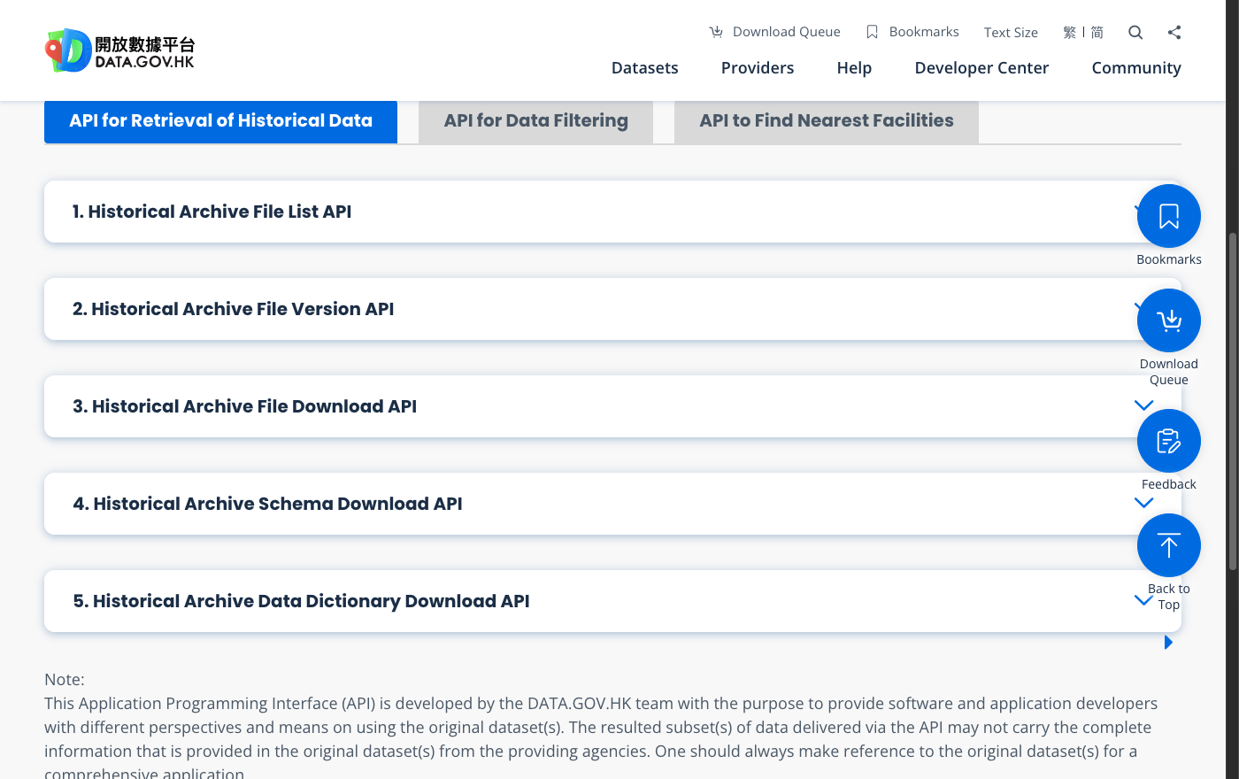
Buried in the developer docs. Five endpoints that together give you every past version of any dataset on the portal.
Two of the five do everything you need:
Endpoint | What it gives you
list-file-versions | Every timestamp the portal has stored, for a date range you choose
get-file | The dataset exactly as it looked at one of those timestamps

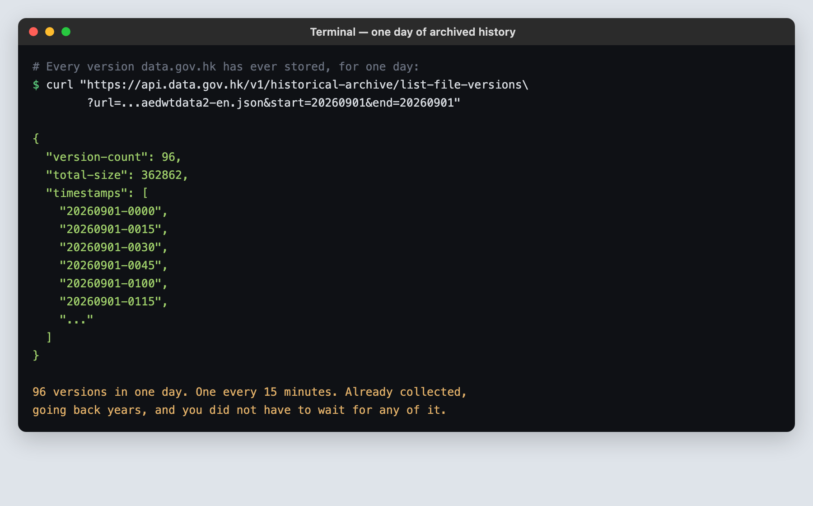
One day of A&E history, asked for and answered. Ninety-six readings, already collected. Ask for a year and you get roughly 35,000.
CHECKPOINT
Before Step 2, your group should be able to say out loud: what the dataset is, how often it updates, where its history lives, and one specific thing it can never tell you. If you cannot answer all four, go back. Building on a dataset you have not understood is how projects die in week three.

Step 2 · Decide what the program is for
You now have data. You do not yet have a product. This step takes twenty minutes and saves days, because it is what stops the AI building a generic dashboard nobody wants.
PROMPT 2 Finding the gap
Here is a dataset: <URL>. Here is a sample of what it returns: <paste 2 records>.
The organisation publishing this shows it to the public as a plain table of
current values.
Tell me three things a member of the public actually wants to know that this
published table does NOT answer. For each one, say what extra information
would be needed to answer it, and whether that information is obtainable.
Do not suggest a dashboard. Do not suggest "visualising the data". I want
three specific questions a real person would ask.
If the answers are vague, your dataset is probably too thin. That is useful to learn now.

For the A&E data, the answer that mattered was the second one: the board says 40 minutes, but is 40 minutes a lot? Nobody can tell, because nobody publishes what this department usually says at 3pm on a Tuesday.

2.1 Write down what it must never do
Before any code exists, decide the lies your program is not allowed to tell. This is unusual and it is the most valuable thing in this tutorial. Written down now, it becomes a rule the AI has to obey. Left unsaid, the AI will cheerfully break every one of them, because a confident answer looks more finished than an honest refusal.
PROMPT 3 The refusal list
I am building: <one sentence describing your app>.
Using: <your dataset>.
Write me a list of rules this program must follow about honesty. Specifically:
- What must it refuse to answer, rather than guess?
- Where could it produce a number that LOOKS correct but means nothing?
- What should it show the user when it does not know something?
Phrase each as a rule I can hold you to later, like "never show a comparison
between X and Y, because they are not measured the same way".

For Arrival, that conversation produced four rules that survived to the finished app:
Rule | Why
Never show a single number, always a range | One number implies a precision this data does not have.
Never compare today's board against a different hour | The board publishes one figure, for now. Scoring it against Saturday 03:00 invents a result.
Never give a travel time where no road exists | One A&E is on an island. Distance times a road factor would advertise a 20-minute drive to Cheung Chau.
Never claim the published figure is right or wrong | Nobody records what patients actually waited. You can only say whether today is usual.

STOP AND THINK
Every one of those rules makes the app say less. Each one was also the reason a real bug got caught later. Discuss in your group: why is a program that refuses to answer more trustworthy than one that always has a figure?

Step 3 · Choose the tech stack by asking, not guessing
A “tech stack” is just the list of tools your program is built from. You have no basis for choosing one, and that is fine. What you do have is the constraints, and constraints are what actually decide the answer. Give the AI the constraints and it will do the choosing properly.
The mistake is to ask “what is the best tech stack?”. There is no such thing, and you will get whatever is fashionable. Ask this instead.
PROMPT 4 Choosing the stack
I need to choose what to build this in. Here are my real constraints:
- I am a student. I cannot pay for hosting, APIs or services.
- It must run on a classmate's laptop by double-clicking one file.
- They cannot type an administrator password or install anything system-wide.
- It must work on Windows and on Mac, on both Intel and Apple Silicon.
- The data is <describe your data and roughly how much of it>.
- I will not be maintaining this for years. It has to be finishable.
Recommend a stack. For every single choice, tell me what it rules out and what
the cheaper alternative would have cost me. If a simpler option would do,
say so and tell me why you did not pick it.
The last two sentences are the important ones. They force a justification instead of a list.

For Arrival that produced this, and each line is a decision with a reason:
Choice | Why this and not something else
Python + Flask for the engine | Flask is pure Python, so nothing has to be compiled for the user's processor. The same folder runs on Intel Mac, Apple Silicon, and both kinds of Windows.
No database, just a JSON file | A database means installing and running a second program. The whole history compresses to under 7 MB, which a plain file handles fine.
React + Vite for the page | The page has to redraw when the user changes a control. Doing that by hand is where beginner projects collapse.
No numpy, no data-science libraries | numpy ships compiled code that must match the user's processor. Dropping it was what made the one-folder promise possible.
uv to install Python itself | It downloads a private Python into the project folder. No admin password, and deleting the folder removes every trace.

3.1 Now make it argue with itself
An AI agrees with you too easily. The recommendation above is worth nothing until it has survived an attack. Paste its own answer back.
PROMPT 5 The counter-argument
You recommended <paste its recommendation> for my constraints.
Now argue the opposite case. What would go wrong with this choice? Which of my
constraints does it strain rather than satisfy? If a different stack would be
better for a student with no coding background, say which and why you did not
recommend it first.
Then tell me honestly which of the two you would actually choose, and what
would have to be true for you to change your mind.

WHAT YOU ARE LEARNING HERE
This is not a trick to get a better answer. It is the habit. An AI produces the most plausible-sounding response, and plausible is not the same as correct. Asking it to attack its own work is the cheapest quality check you have, and it takes thirty seconds.

Step 4 · Collect the data
Now the AI starts writing code. You still will not. Your job is to be specific about what you want and to check what comes back.
PROMPT 6 Building the collector
Write me a Python script that downloads the history of this dataset from
the data.gov.hk historical archive.
The dataset is: <URL>
The archive API is documented at: https://data.gov.hk/en/help/api-spec
Requirements:
- Sample <N> months back. Take a few days per month, not every day: I want
weekday peak, weekday off-peak and weekend covered, not maximum volume.
- Save everything into one file in a data/ folder.
- The archive rate-limits and returns errors if you go too fast. Handle that
and retry rather than crashing.
- Print progress as it goes, so I can tell it is working.
- If a download fails, say which one and keep going. Do not lose the rest.
Before you write it, tell me roughly how big the file will be and how long
this will take to run.
Making it estimate first is how you avoid starting a four-hour download by accident.

Then run it, and check it
Ask the AI to run the script for you. When it finishes, do not take its word that it worked. Ask:
PROMPT 7 Verifying the collection
How many distinct days did that actually collect, how many readings in
total, and what is the earliest and latest timestamp in the file?
Show me the real counts read from the file, not what the script intended to
collect. If any days are missing, list them.

Arrival ended up with 290 days, 23,422 readings, and 421,596 individual hospital observations. You need those numbers, because they are what you put on screen when a user asks how much evidence is behind an estimate.

Step 5 · Commute time, and the Google Maps MCP server
Arrival answers “which hospital gets me seen soonest”, not “which has the shortest queue”. Those are different questions, and the difference is travel time. This step is the most interesting in the project, because the obvious tool turns out to be the wrong one to ship, and working out why is the lesson.
PROMPT 8 How do I even get travel time?
My app needs to know how long it takes to get from a user's location to
each of 18 hospitals, by car and by public transport, in Hong Kong.
What are my options? For each one tell me:
- Does it cost money, and does it need a credit card on file?
- Does it need the user to be online?
- How accurate is it really?
- What happens to my app when it is unavailable?
I am a student with no budget and my app must keep working if a service
goes down.

5.1 What an MCP server is
An AI on its own can only write text. An MCP server is a plug-in that gives it a real capability: reading your files, searching the web, or in this case talking to Google Maps. You install one, and new tools appear that your AI can use on your behalf.
Think of it as the difference between an assistant who can describe how to look something up and one who can actually go and look it up.

5.2 Get a Google Maps key
1. Go to console.cloud.google.com and sign in with any Google account.
2. Create a new project. Call it anything.
3. In the search bar type “Directions API” and enable it. Do the same for “Geocoding API”.
4. Go to Credentials, click Create credentials, choose API key, and copy it.
5. Google asks for a card to activate billing. There is a free monthly allowance well beyond anything this tutorial needs, but if your group would rather not, skip to 5.5: the finished app does not need this key to run.
TREAT THE KEY LIKE A PASSWORD
An API key is a credential. Never paste one into a chat window, a shared document, or a file you will upload to GitHub. It goes in one local config file and nowhere else. If you ever think you have leaked one, delete it in the Google console immediately: keys can be deleted and replaced in seconds.

5.3 Install the server
Create a file called .mcp.json in your project folder, with exactly this in it. Ask your AI to create it if you would rather not make files by hand.
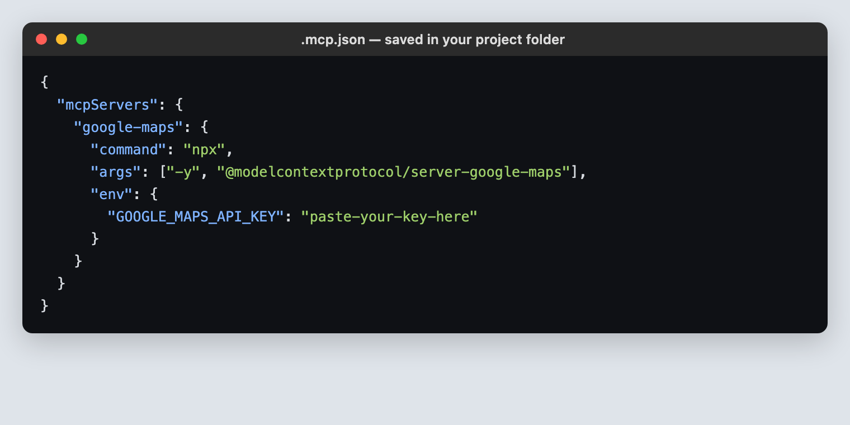
The whole configuration. Replace the placeholder with your key and nothing else changes.
Restart your AI tool so it picks the file up, then check it worked. In Claude Code, type /mcp.
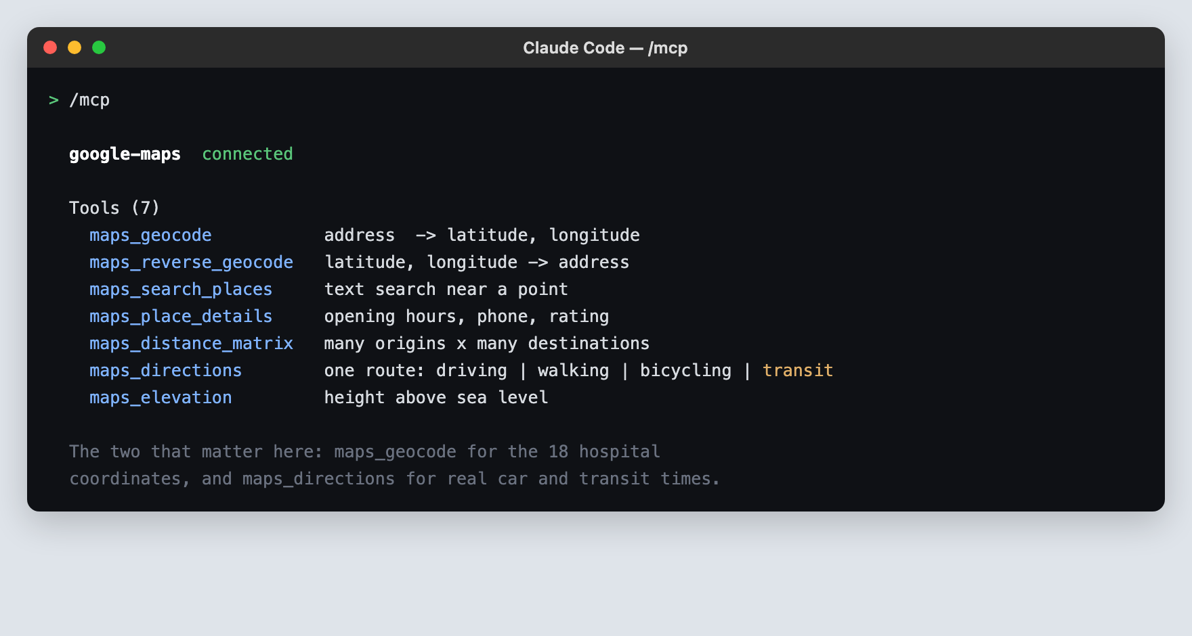
Seven new tools the AI can now use. Two of them do the work in this project.

5.4 Use it for the thing it is genuinely best at
The app needs the latitude and longitude of all 18 emergency departments. Looking those up by hand is an afternoon of tedious work with a real chance of a typo putting a hospital in the sea.
PROMPT 9 Geocoding, with a tool
Use the google-maps MCP server. For each of these 18 hospitals, use
maps_geocode to find its latitude and longitude:
<paste the list of hospital names exactly as they appear in the dataset>
Then write them into a Python dictionary keyed by the hospital name, spelled
exactly as the dataset spells it, so it can be looked up directly.
Afterwards, check your own work: plot roughly where each one landed and tell
me if any of them are not in Hong Kong, or are in the sea, or are suspiciously
far from where that hospital actually is.
The self-check is not optional. Geocoding a name like “St John Hospital” can easily return a church.

5.5 Now the real decision: what ships?
Google Maps can give you a genuinely good car and public-transport time. So why does the finished app not use it? Ask the AI to lay out the trade, then decide as a group.
PROMPT 10 Should Maps ship, or only help?
I can compute travel time two ways:
(a) Call the Google Maps Directions API live, every time a user asks.
(b) Build a model from a free, keyless public data source, and use Google Maps
only while developing, to check my model is close.
My app will be run by classmates on their own laptops, from a folder they
downloaded. Walk me through what happens under (a) when: my key is in the
downloaded folder; 30 people run it at once; I run out of free quota; Google
changes its pricing.
Then tell me what (b) costs me in accuracy.

For Arrival the answer was (b), for one blunt reason: option (a) means your key ships inside the folder, where any of those 30 classmates can read it and spend your quota. So the app uses two free sources instead.
Mode | How the shipped app computes it
Car or taxi | Live speeds from around 750 Transport Department road detectors. It takes the detectors within 2 km of the straight line from you to the hospital, averages their speeds, and divides the distance by that. Free, no key, updated constantly.
Public transport | Hong Kong has no free point-to-point transit routing API, so the app uses a speed model: 22 km/h for the travelling portion, plus 10 minutes for walking to the stop, waiting, and walking in at the other end.
St John Hospital | Neither. It is on Cheung Chau, a car-free island with no road link. The app returns no travel time at all and says why.

Two details in the car calculation are worth understanding, because they are the kind of thing an AI will skip unless you ask.
Detail | Why it is there
Straight-line distance is multiplied by 1.35 | Roads bend and harbours need tunnels, so the real driving distance is always longer than the straight line. 1.35 is the usual ratio for dense cities.
The speed is capped at 60 km/h and floored at 8 km/h | The detectors sit on expressways where traffic moves at 80-100 km/h. No real door-to-door trip averages that, because it includes side streets and traffic lights. Without the cap, a clear tunnel produces a fantasy arrival time.

5.6 Use Maps to check your model
This is where the MCP server earns its place. You built a model. Google Maps knows the real answer. Compare them.
PROMPT 11 Calibrating against the real thing
Use the google-maps MCP server. Pick 10 varied journeys from my app:
short, long, cross-harbour, and one to the most remote hospital.
For each, call maps_directions twice: once with mode "driving" and once with
mode "transit". Record what Google says.
Then run my own model on the same 10 journeys and put both sets of numbers
side by side, with the difference in minutes and as a percentage.
Where my model is worst, tell me WHY, in terms of what my model does not know.
Do not change my constants to make the numbers match. I want to understand the
error, not hide it.
“Do not change my constants to make the numbers match” matters. Without it, an AI will quietly tune the model until the test passes.

THE RESULT, AND THE LESSON
Arrival's car model came out within a few minutes on most journeys and badly wrong on cross-harbour trips, where the true road-distance ratio is closer to 2 than 1.35. That was not hidden. It was written into the sentence the app shows the user: “cross-harbour trips will be understated”. A known, stated error is a feature. A hidden one is a defect.

Step 6 · The statistics, and the honesty rule
You have 290 days of history. Turning that into “is today normal?” is the statistical core, and you do not need to know any statistics to direct it, only to insist on knowing what each number means.
PROMPT 12 What does normal look like?
I have <N> days of readings for each hospital, taken every 15 minutes.
Each reading is that hospital's published wait at that moment.
I want to answer: "is the number on the board right now normal for this
hospital, at this hour, on this day of the week?"
Build that. Then explain to me, in plain English and with no statistical
jargon:
- What exactly you are comparing against
- Why you chose that comparison and not a simpler average
- How few readings is too few for the answer to mean anything, and what the
program does when it has too few
I have no statistics background. If I cannot explain your method to a
classmate, it is the wrong method.
The last line is the real requirement. A method you cannot explain is a method you cannot defend.

Arrival's answer, which you should be able to explain in one breath:
Idea | In plain words
Bucket by hour of week | Every reading goes into one of 168 boxes: Monday 00:00, Monday 01:00, and so on. Tuesday 3pm is only ever compared against other Tuesday 3pms.
The middle half | Sort a box's readings and take the middle 50%. That range is “normal” for this department at this hour.
The 1-in-20 tail | The feed also publishes a figure that 19 in 20 patients are seen within. That is the number to plan around, not the middle.
Too few readings | Under 5 readings in a box, the app widens to nearby hours and says so on screen. Still too few, and it refuses to answer.

6.1 Enforce the refusal list
Remember the rules from Step 2. Now is when you make the AI obey them, because this is the point where a comparison that should not exist will quietly appear.
PROMPT 13 The honesty pass
Here are the honesty rules I set at the start: <paste your refusal list>.
Go through what you have built and find every place it breaks one of them.
For each, show me the exact line, explain how a user would be misled, and
what it should do instead.
Pay particular attention to comparisons between two numbers that were not
measured at the same time or in the same way. Those are the ones that look
fine and are not.

On Arrival this pass found a real one. The app was comparing today's live board against whichever hour the user had selected. On a Tuesday at 17:00, one hospital's single reading produced four different “results” for four different hours, and the page presented each as an observation. Nothing crashed. No error appeared. It simply was not true.
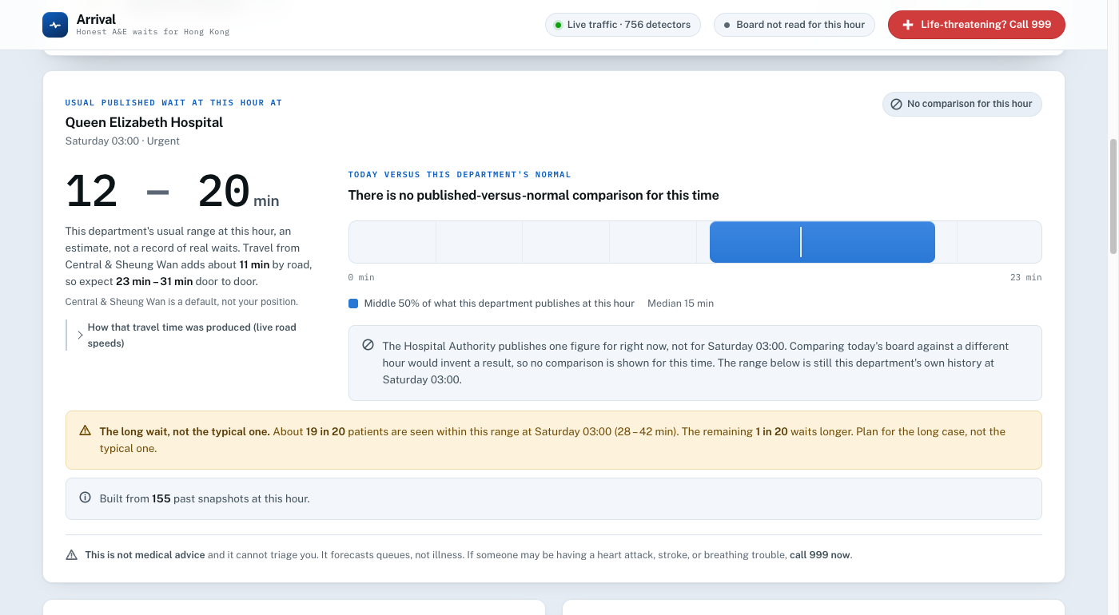
The fix. Outside the current hour there is no comparison, and the app says so in a sentence rather than leaving a blank or inventing a figure.

Step 7 · The interface
AI-generated web pages have a look: a centred box, a purple gradient, three cards in a row, and a font nobody chose. It is instantly recognisable and it makes your work look unconsidered. Getting past it takes two things: asking the right question, and using a skill.

7.1 What a skill is
A skill is a set of expert instructions your AI loads before starting a task. Where an MCP server gives it a new capability, a skill gives it judgement it would not otherwise apply. You invoke one by name and it changes how the AI approaches the whole job.
Skill | What it changes
design-taste-frontend | Makes the AI pick a specific visual direction and commit to it, instead of producing the default template. Audits what exists before redesigning.
dataviz | Chart design done properly: which chart form actually fits the data, colours that survive colour-blindness, and axes that do not mislead.
app-design | For when an interface already exists and looks generic. Rebuilds the shell before the surface.

In Claude Code you invoke one by typing a slash and its name. If your tool has no skills, paste the same intent as a long instruction instead; the point is to make the AI commit to a design direction before it writes any markup.

7.2 Ask what to build it in, before what it looks like
PROMPT 14 The interface stack
My page needs to redraw whenever the user changes a control, and it shows
two charts and a table of 18 rows.
What should I build the interface in, given that my classmates must be able to
run it by double-clicking one file with no internet after the first setup?
Tell me what gets ruled out by that offline requirement, and whether I need a
charting library or whether the charts are simple enough to draw directly.

7.3 Then the design
PROMPT 15 The design pass
/design-taste-frontend
Build the interface for this app. Before you write any markup, tell me the one
visual direction you are committing to, in a single phrase, and stick to it.
Hard requirements:
- Every wait is shown as a range, never a single number.
- When the app cannot answer, the explanation takes the space the answer would
have taken. It is not a footnote and not a greyed-out box.
- Someone frightened, on a phone, at 3am must find the answer in one glance.
- Do not use a purple gradient. Do not centre everything in a card.
“Tell me the direction before you write markup” is the whole trick. It forces a decision you can accept or reject.

Arrival's answer was “an arrival instrument”: words in one typeface, every number in a monospaced one so figures line up in columns, hairline rules, a calm near-white page and exactly one accent colour. Stated in one phrase, and then visible in every part of the result.
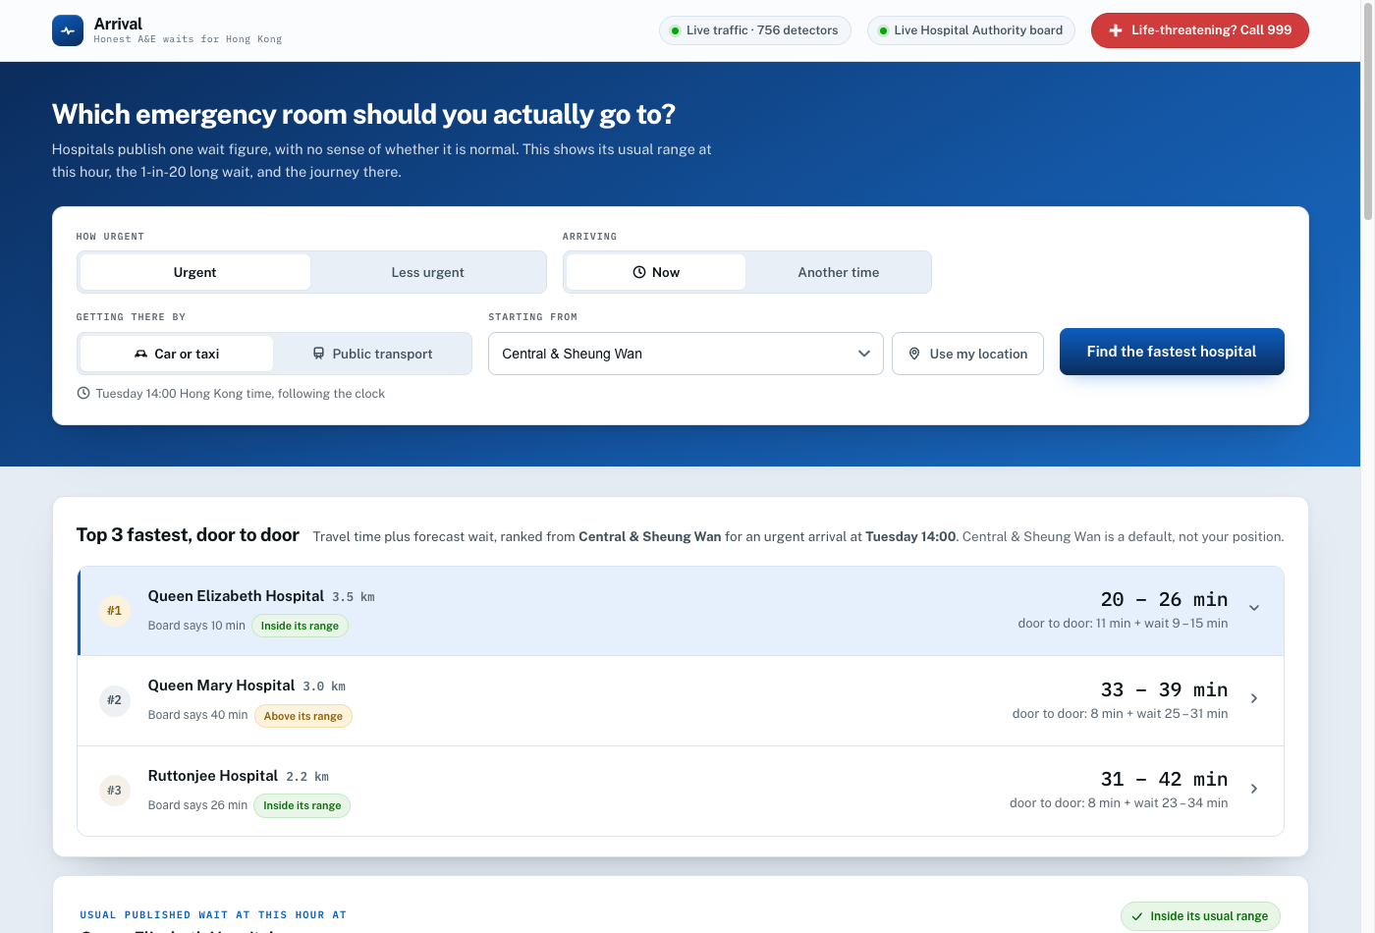
The result. Controls at the top, the answer immediately underneath, no decoration that is not carrying information.
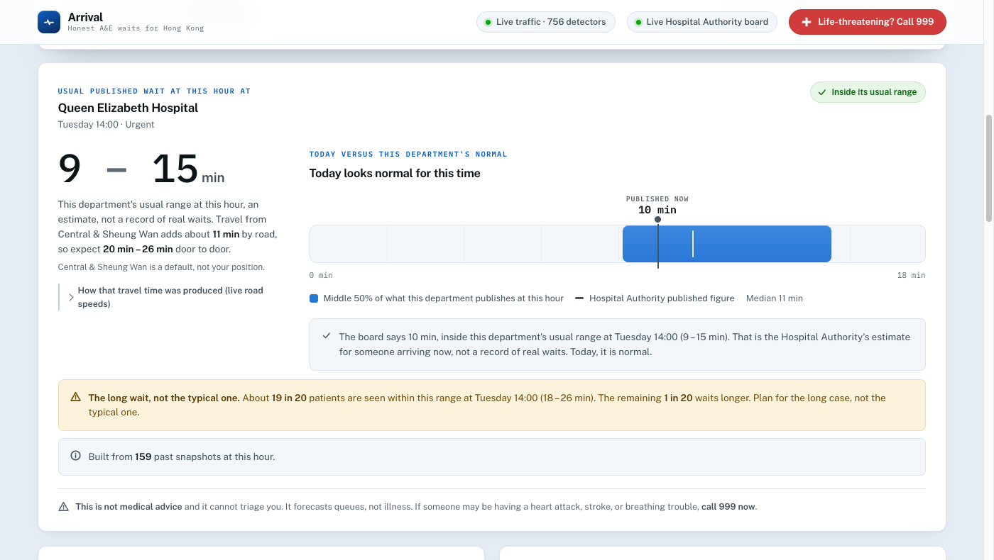
The chart the dataviz skill produced. The blue band is this department's normal range at this hour and the black line is today. One glance answers the question.

Step 8 · Make it run on someone else's laptop
A program that only runs on the machine it was built on is not finished. This is the step where student projects usually stop, and it is the one that makes the difference between a demo and a thing.
PROMPT 16 The launcher
Write me a launcher that someone with no technical knowledge can
double-click to run this app.
It must:
- Work on Windows, on Intel Mac and on Apple Silicon Mac
- Install everything it needs, including Python itself, without an
administrator password
- Put everything it installs INSIDE this project folder, so deleting the
folder removes every trace
- Open the browser automatically once the app is actually responding
- If something goes wrong, say what in plain English, and keep the window open
so the message can be read
Write one for Windows and one for Mac. Then tell me every way this could fail
on a computer that is not mine, and what the user would see in each case.
That final question is the one that finds the bugs. Ask it about every piece of the project.

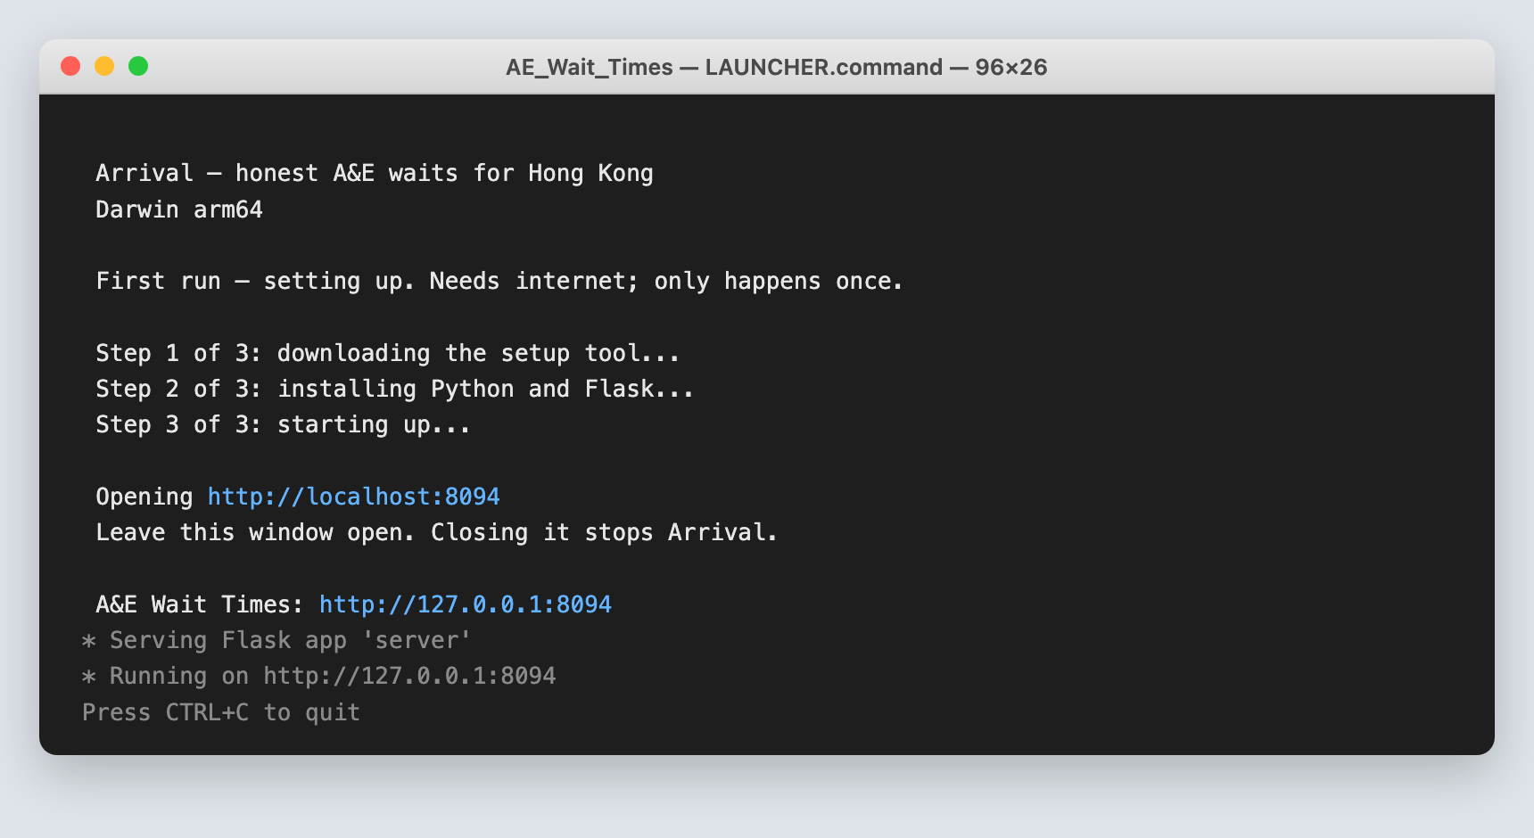
What a classmate sees. Three steps, then a link. No instructions needed.

Step 9 · Try to break it
You are nearly done, which is exactly when a project is most likely to be quietly wrong. Three things, in order.

9.1 Tests
A test is a small check that runs automatically and fails loudly if the program stops doing what it should. You will not write them.
PROMPT 17 Tests
Write tests for this project. I care most about:
- The honesty rules from Step 2. Each one should have a test that fails if the
rule is broken.
- The statistics. If I change how a forecast is computed, a test should fail
and tell me the numbers moved.
- The refusals. Test that it DOES refuse when it should.
Then run them and show me the output.

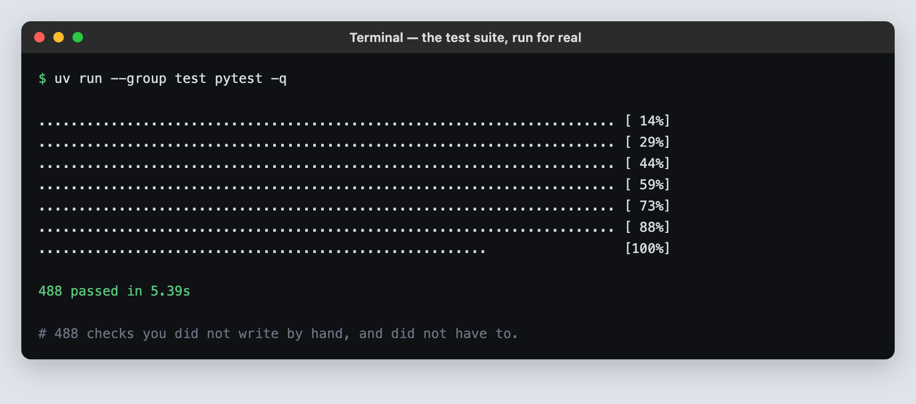
Arrival's suite. 488 checks, none of which anyone typed by hand.

9.2 A review
Ask for a fresh pair of eyes on the whole thing. In Claude Code, /code-review does this. Elsewhere, ask in plain words.
PROMPT 18 The review
Review this whole project for correctness bugs.
Pay special attention to anything that would behave differently on a computer
that is not this one: a different operating system, a different language
setting, a different timezone, no internet.
For each thing you find, tell me what the user would actually SEE. I do not
want a list of style opinions.

9.3 A worked example of what this catches
Arrival worked perfectly on the Mac it was built on. On the first Windows machine it was tried on, it did not start at all. The window filled with red text and closed.
The cause: the program asked the computer what time it was in Hong Kong. Mac and Linux carry a built-in table of the world's timezones. Windows does not, and nobody had told the project to bring its own. One missing line in a settings file, and the program died before it reached its first instruction.
What it teaches | The general lesson
“It works on my machine” is not a test | It only proves the program works in the exact conditions it was built in.
The failure was total, not partial | The app did not run badly. It did not run. Those are the easiest bugs to find and the most embarrassing to ship.
An AI will not catch this unprompted | It was not asked to think about Windows. Prompt 18 exists because of exactly this.

TEST ON A MACHINE THAT IS NOT YOURS
Before you hand anything in, run it on a classmate's laptop, ideally one with a different operating system from yours. Watch them do it without helping. Every place they hesitate is a defect, even if nothing crashed.

Step 10 · Do it again with your own dataset
The eighteen prompts above are not about A&E waiting times. They are a recipe. Here they are in order, with what each is for.
# | Prompt | What it is for
1 | Evaluating a dataset | Is this worth building on at all?
2 | Finding the gap | What does nobody currently answer?
3 | The refusal list | What must this never claim?
4 | Choosing the stack | Constraints in, decisions out
5 | The counter-argument | Make it attack its own answer
6 | Building the collector | Get the history
7 | Verifying the collection | Check what you actually got
8 | How do I get travel time? | Survey the options honestly
9 | Geocoding, with a tool | Use an MCP server for facts
10 | Should Maps ship, or only help? | Decide what goes in the product
11 | Calibrating against the real thing | Measure your error, do not hide it
12 | What does normal look like? | The statistics, explainably
13 | The honesty pass | Enforce prompt 3
14 | The interface stack | What to build the page in
15 | The design pass | Commit to a direction
16 | The launcher | Make it run elsewhere
17 | Tests | Lock in what must stay true
18 | The review | Find what you did not think of

10.1 Datasets that would work
Each of these is published, updated, archived by the same data.gov.hk history API, and as far as anyone can tell not yet made useful to the public. Pick one nobody else in the class has.
Dataset | The question nobody answers
Carpark vacancies | Is this carpark unusually full for a Saturday afternoon, or is it always like this?
Air quality by district | Is today bad, or is this district always bad and nobody says so?
Public swimming pool and sports facility bookings | When is my local pool actually quiet?
Bus and minibus journey times | Which route is unreliable, as opposed to merely slow?
Public library catalogue and availability | Where is the copy I want, closest to me, on the shelf today?

THE QUESTION TO TAKE AWAY
You directed the building of a working application and you did not write code. That is not the interesting part, and it will be ordinary within a few years. The interesting part is that at four separate points the AI would have produced something confident and wrong, and it was stopped by a person who insisted on knowing where the number came from. That person is the one the job still needs.

IF YOU PUBLISH IT
Anything you build on health, safety or emergency data must say plainly what it is not. Arrival carries “not medical advice, call 999” on every screen and in its footer. Work out the equivalent sentence for your project before anyone else sees it, not after.

